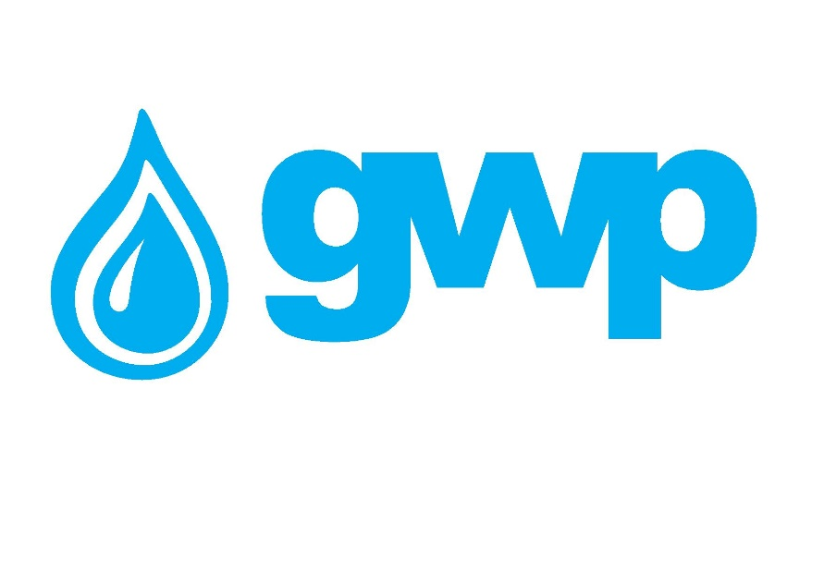

E-Tender Documentation of Samgori water filtering station’s settlement tanks and filters upgrade feasibility study and its technical design

1.1 Title of procurement
Georgian Water and Power LLC announces electronic tender for the procurement of feasibility evaluation and technical design of the project for upgrading the Samgori water filtering station’s settlement tanks and filters.

Purpose of the mentioned Tender is to replace the Existing Samgori water building with the new and modern technology, for the implementation of the aforementioned objective the following actions have to be accomplished:
-To connect the receiving camera on the existing entry lines;
-To construct the new settlement tank;
-To install new filters;
-To replace the existing chlorination system with new one;
-To connect the existing filters on the existing network;
-To rectify the system

Special requirements:
- The winner company shall develop a feasibility analysis of the project for upgrading the Samgori water filtering station, as well as technical design/graphical drawings and preliminary cost estimation of the project.
- Preliminary cost estimation shall be based on the Decree N152 of the Prime Minister of Georgia made on January 14, 2014 on Validity of Operation and Recognition of Technical Regulations of Construction in Georgia, according to which the construction regulations that had been active before 1992, are recognized and in force. The preliminary cost estimation shall be presented by construction resources (13-digit code) with indication of labor (man-hour) and machine (machine-hour) costs.
- Expertize of the graphical design and preliminary cost estimation of the project shall be carried out by an officially recognized agency in accordance with construction resources prices specified in the quarterly publication of the Construction Evaluators’ Union.
- The winner company shall provide a professional liability insurance certificate for the submitted project to be issued by an insurance company approved by the Client. Insurance coverage shall be at least equal to the total amount of estimated project costs.
Note: GWP LLC gives all interested companies are obliged to visit Samgori water filtering station before submitting bids.Should you be interested in visiting the facility, please contact our representative: Davit Dvali, Tel.: 595 088 119

1.2 Description of service/work (Terms of Reference), quantity/volume of procurement

Samgori water filtering station is one of the five water intake facilities of GWP. Samgori water filtering station is located at 163 Gakhokidze street, at 515-535 m above sea level. The station was commissioned in 1952. Its capacity varies within 4000-5000 l/sec. Samgori water filtering station incorporates 50 units of filters, chlorinators, reservoirs and pumping station which serve the water distribution network. The station receives pumped raw water from the Tbilisi Sea and Zhinvali water reservoir. Samgori water filtering station feeds 12 water supply pipes, which serve Samgori and Isani districts, part of Gardabani and Krtsanisi districts – more than 104,000 consumers.

Additional technical details will be communicated only to interested persons after signing a non-disclosure agreement. In Case of interest please contact Tekla Murvanidze, tmurvanidze@gwp.ge

1.3 Cost estimation
A bidder shall provide at least one cost estimation is accordance with the below price list.
1.4 Deadline for delivery of goods / services / works
Within the pre-agreed period from the signature date of the contract.
1.5 Form and place for delivery of goods / service / works
Tbilisi.
1.6 Certification of bidder’s experience

The bidder shall have experience in performing works similar to the scope of procurement and submit relevant supporting documents: contract(s) and associated delivery-acceptance document(s) and/or reference number of the mentioned documents in Georgian procurement electronic system of the State Procurement Agency (e.g., NAT/CMR/SPA, etc.).

1.7 Terms of payment
Payment shall be made by transfer, within the period of 30 (thirty) calendar days from the submission of delivery-acceptance documents.

Prepayment of 30% of the total contract amount will be allowed only on the basis of a bank guarantee.

1.8 Performance Guarantee

The Contractor shall present a performance guarantee in an amount of 5% of the contract value within 7 (seven) calendar days from the signature date of the Contract. The performance guarantee shall be issued by a bank licensed in Georgia or OECD member state (Organization of Economic Cooperation and Development). The term of validity of the guarantee shall be at least 60 calendar days longer than the term of the contract. In case the Contractor fails to present the guarantee within the agreed period of time, the Client shall be entitled to terminate the Contract.

1.9 Information to be uploaded/provided by bidders for electronic tender:
1. Price list with consideration of special requirements (paragraph 1.1 and 1.3);
2. Documents demonstrating experience of a bidder in accordance within the paragraph 1.6;
3. Information regarding preferred terms of payment (paragraph 1.7);
4. Extract from the Registry of entrepreneurial and non-entrepreneurial (non-commercial) legal entities issued after the announcement date of the electronic tender.
Note:
1) All documents and/or information uploaded for the electronic tender by a bidder shall be signed by an authorized person (a letter of attorney shall be uploaded whenever required);
2) It is Preferable All documents and/or information prepared by a pretender to be verified by an authorized person using electronic signature or a stamp of the company.
1.10 Concluding a contract
1) A contract with the winner company will be signed in accordance with the terms of this tender.
2) Georgian Water and Power LLC reserves the right to sign a contract with one or more companies.

1.11 Other requirements
1.11.1 When submitting a bid, a bidder shall not be:
- in the process of filing for bankruptcy
- in the process of liquidation
- in conditions of suspended business activity.

1.11.2 Cost estimation shall be made in Georgian national currency (GEL). Prices must include all costs considered by this tender and taxes specified by the Georgian legislation.
1.11.3 Offer of the bidder shall be valid for 30 (thirty) calendar days from the date of its submission.
1.11.4 Georgian Water and Power LLC reserves the right to determine by itself the tender completion time, to change the tender terms under the notification timely given to the bidders, or to terminate the tender at any stage of its progress.
Georgian Water and Power LLC will identify the winner through the tender commission and inform all participating companies thereof. Georgian Water and Power LLC is not obliged to give a verbal or written explanation to any bidder on any decision made regarding to the tender.
Georgian Water and Power LLC reserves the right to verify any information received from the bidders as well as to obtain information about the company or its activities. If the information provided by a bidder is not true or false, the bidder will be disqualified.
Please, note that Georgian Water and Power LLC will not accept oral request for additional information. Only phone inquiries will be accepted.
Note: Any other information obtained in any other way will not be considered as official and does not generate any obligation from Georgian Water and Power LLC.

1.12 Information for participation in electronic tender:
1.12.1 Any question during the electronic tender process shall be made in writing and communicated through the Q&A platform of tenders.ge website;
1.12.2 To participate in the electronic tender, the company shall be registered on www.tenders.ge;
1.12.3 For instruction on participation in electronic tender through tenders.ge please refer to Annex 4.

Contact information:
Contact person: Mariam Silagadze
Address: 10 Medea (Mzia) Jugeli str., 0179, Tbilisi
E-mail: msilagadze@gwp.ge
Tel.: +995 32 2 93 11 11 (1147); 599 72 30 03

Contact person: Tekla Murvanidze
Address: 10 Medea (Mzia) Jugeli str., 0179, Tbilisi
E-mail: tmurvanidze@gwp.ge
Tel.: +995 322 931111 (1141); 595 523 381

